Name: D.Darshan Course code:DSA0602
Reg no:192524117

Class Activity: 10.07.2026

Scenario 1: Student Academic Performance Dashboard
Code:
import pandas as pd
import matplotlib.pyplot as plt
import seaborn as sns

df = pd.read_csv("scenario1_student_academic_performance.csv")

plt.figure(figsize=(8,5))
sns.scatterplot(data=df,
x="Attendance (%)",
y="Internal Marks",
hue="Department",
s=120)

plt.title("Student Academic Performance Dashboard")
plt.xlabel("Attendance (%)")
plt.ylabel("Internal Marks")
plt.legend(title="Department")
plt.show()

Output:
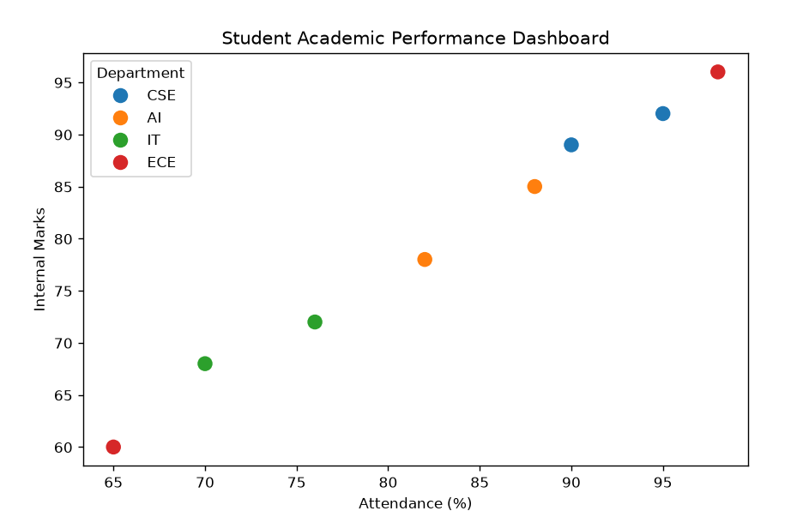

Scenario 2: Electric Vehicle Market Analysis
Code:
import pandas as pd
import matplotlib.pyplot as plt
import seaborn as sns

df = pd.read_csv("scenario2_ev_market(1).csv")

plt.figure(figsize=(8,5))

sns.scatterplot(data=df,
x="Battery Capacity (kWh)",
y="Price",
hue="Manufacturer",
size="Driving Range",
sizes=(100,700))

plt.title("Electric Vehicle Market Analysis")
plt.xlabel("Battery Capacity (kWh)")
plt.ylabel("Price")
plt.show()

Output:

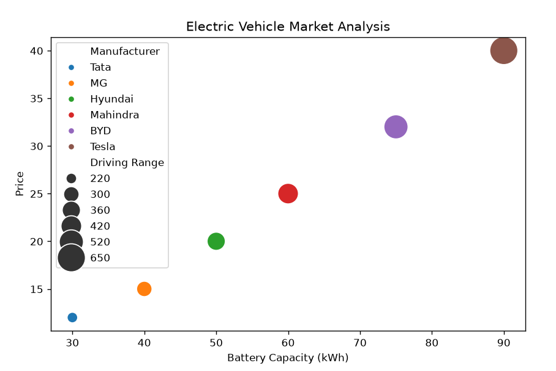

Scenario 3: Hospital Patient Admission Analysis

Code:
import pandas as pd
import matplotlib.pyplot as plt

df = pd.read_csv("scenario3_hospital_admissions.csv")

plt.figure(figsize=(8,5))

bars = plt.bar(df["Department"],
df["Number of Patients"],
color=["red","blue","green","orange","purple"])

for bar,cost in zip(bars,df["Average Treatment Cost"]):
plt.text(bar.get_x()+bar.get_width()/2,
bar.get_height()+2,
f"₹{cost}",
ha="center")
plt.title("Hospital Patient Admission Analysis")
plt.xlabel("Department")
plt.ylabel("Number of Patients")
plt.show()

Output:
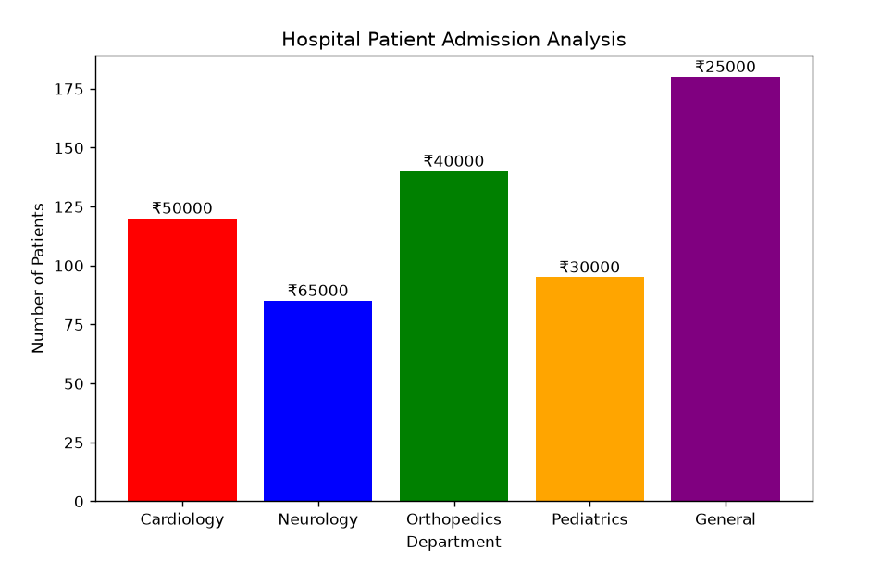

Scenario 4: Weather Monitoring System
Code:
import pandas as pd
import matplotlib.pyplot as plt

df = pd.read_csv("scenario4_weather(1).csv")

plt.figure(figsize=(9,5))

styles = ["-","--",":"]

for i,city in enumerate(df["City"].unique()):
temp = df[df["City"]==city]
plt.plot(temp["Date"],
temp["Temperature"],
linestyle=styles[i],
marker="o",
label=city)

plt.title("Weather Monitoring System")
plt.xlabel("Date")
plt.ylabel("Temperature")
plt.legend()
plt.show()

Output:
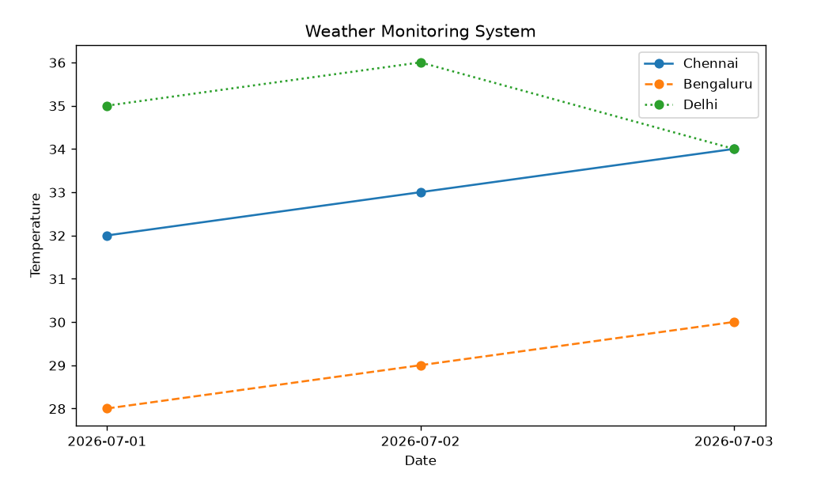

Scenario 5: Supermarket Sales Analysis
Code:
import pandas as pd
import matplotlib.pyplot as plt

df = pd.read_csv("scenario5_supermarket_sales(1).csv")

pivot = df.pivot(index="Product Category",
columns="Branch",
values="Sales Amount")

pivot.plot(kind="bar",figsize=(8,5))

plt.title("Supermarket Sales Analysis")
plt.xlabel("Product Category")
plt.ylabel("Sales Amount")
plt.show()

Output:
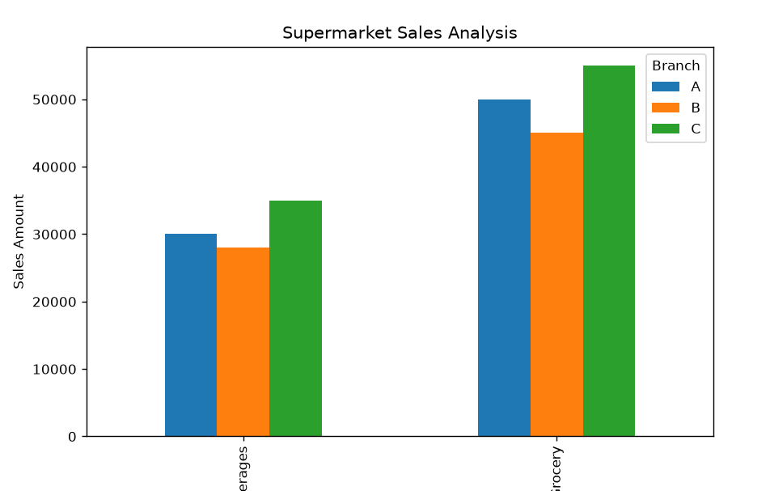

Scenario 6: Employee Salary Distribution
Code:
import pandas as pd
import matplotlib.pyplot as plt

df = pd.read_csv("scenario6_salary(1).csv")

plt.figure(figsize=(8,5))

plt.hist(df["Salary"],
bins=5,
color="skyblue",
edgecolor="black")

plt.title("Employee Salary Distribution")
plt.xlabel("Salary")
plt.ylabel("Frequency")
plt.show()

Output:

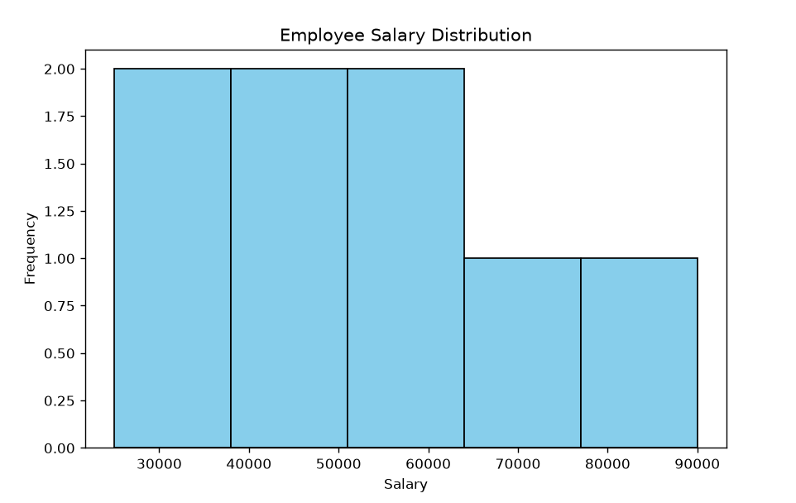

Scenario 7: Smartphone Market Comparison
Code:
import pandas as pd
import matplotlib.pyplot as plt

df = pd.read_csv("scenario7_smartphones(1).csv")

plt.figure(figsize=(8,6))

scatter = plt.scatter(df["RAM"],
df["Price"],
s=df["Storage"],
c=df["Processor Speed"],
cmap="viridis")

for i,brand in enumerate(df["Brand"]):
plt.text(df["RAM"][i],
df["Price"][i],
brand)

plt.colorbar(scatter,label="Processor Speed")

plt.title("Smartphone Market Comparison")
plt.xlabel("RAM")
plt.ylabel("Price")
plt.show()

Output:
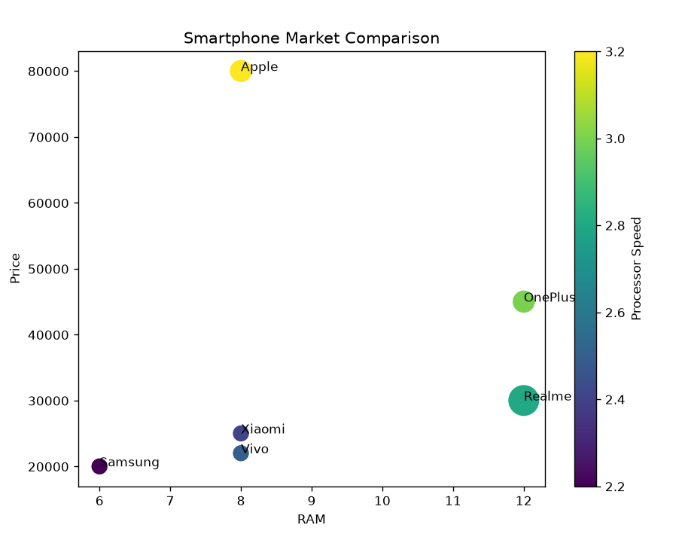

Scenario 8: Online Movie Rating Analysis
Code:
import pandas as pd
import matplotlib.pyplot as plt
import seaborn as sns

df = pd.read_csv("scenario8_movie_ratings.csv")

pivot = df.pivot(index="Genre",
columns="Release Year",
values="Average Rating")

plt.figure(figsize=(6,5))

sns.heatmap(pivot,
annot=True,
cmap="YlOrRd")

plt.title("Online Movie Rating Analysis")
plt.show()

Output:
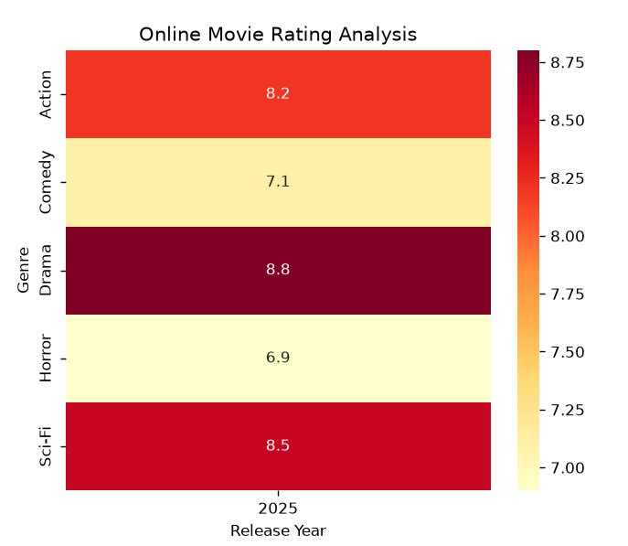

Scenario 9: COVID-19 State-wise Analysis
Code:
import pandas as pd
import matplotlib.pyplot as plt
import seaborn as sns

df = pd.read_csv("scenario9_covid_states.csv")

plt.figure(figsize=(6,5))

sns.heatmap(df[["Active Cases"]],
annot=True,
yticklabels=df["State"],
cmap="Reds")

plt.title("COVID-19 State-wise Active Cases")
plt.show()

Output:
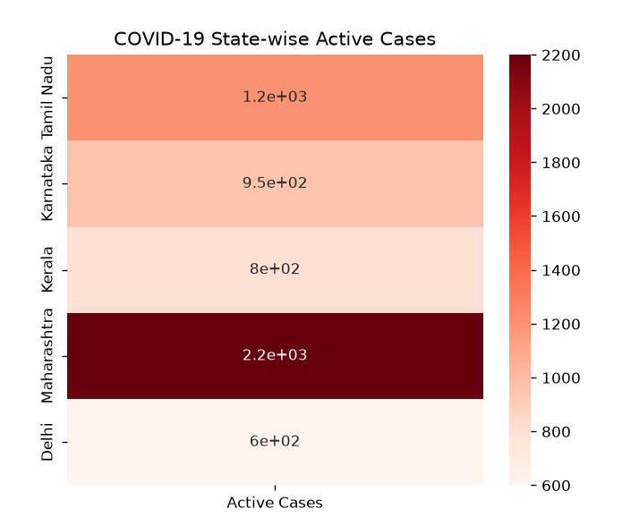

Scenario 10: Iris Flower Classification
Code:
import pandas as pd
import matplotlib.pyplot as plt
import seaborn as sns

df = pd.read_csv("scenario10_iris_sample(1).csv")

plt.figure(figsize=(8,6))

sns.scatterplot(data=df,
x="Sepal Length",
y="Petal Length",
hue="Species",
style="Species",
size="Sepal Width",
sizes=(50,300))

plt.title("Iris Flower Classification")
plt.xlabel("Sepal Length")
plt.ylabel("Petal Length")
plt.show()

Output:
